**100 Years Journey of The Journal of The Indian Botanical Society**



**The Indian Botanical Society**



**Editorial**

**From the Archives of the Journal of The Indian Botanical Society**

A journey spanned over 100 years calls for an occasion to celebrate and introspect. All the papers published in the journal till date are available online in digital form. However, to provide a glimpse and portray the spectrum of publications spread over the long span of 100 years it is considered desirable to put together a representative set in one place. 116 such publications are presented here from the journal archives. An attempt is made to represent all branches of botanical sciences as well as the botanists of different era who nurtured the journal over the years. Readers may find it interesting that whereas some botanists have preferred to work in specialized areas, but most of the botanists of earlier generations have excelled in general botany extending their work to several specific areas across the different plant groups with equal command, e.g. SR Kashyap, MOP Iyengar, B Sahni, P Maheshwari, PN Mehra, P Kachroo, to name a few.

While writing these lines I am tempted to reproduce a microphotograph from the journal archives showing metaphase chromosomes prepared from the cellular endosperm of *Cocos nucifera*, representing middle layer. Such pictures are testimony to the marvel of work done in the olden days for its technical excellence and scientific significance, but also demonstrate a classic example of ontogenetic endopolyploidy. It may not be out of place to mention here that opposed to such ontogenetic incidences of endopolyploidy, a recurrent somatic reduction is the normal ontogenetic process in apogeotropic coralloid roots of cycads happening between pericycle and endodermis (*Science*, 1968. DOI: 10.1126/science.159.3815.648).

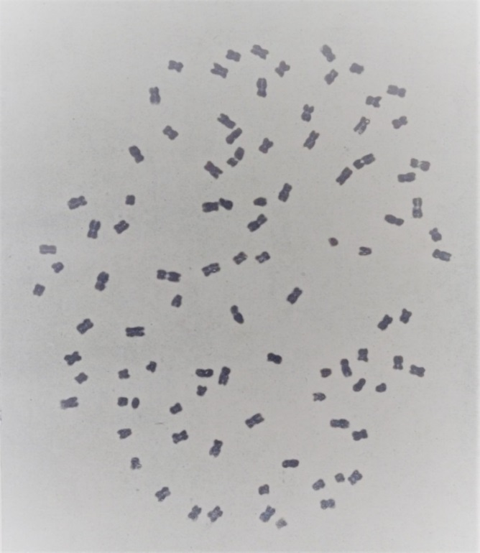

Figure - Somatic chromosomes of *Cocos nucifera*, 6x=96. Note : *Cocos nucifera* contains 2n=32; its endosperm - comprising a triple fusion product is supposed to contain 3x=48. This picture showing 96 chromosomes is from the middle layer of endosperm. (source, *Jour Indian bot Soc* 42A, plate I, 1963, by A Abraham)

The Indian Botanical Society owes its inception in a resolution passed by the Botany Section of the Indian Science Congress on January 07, 1920 during its Nagpur session. After fulfilling the necessary procedural formalities and organizational pre-requisites, the formation and organization of the society was formally declared on 6th December 1920. However, the scientific organ of the society owes its genesis in a journal named “*The Indian Journal of Botany*” – edited by Mr. PF Fyson of the Presidency College, Madras. This journal was initiated to provide a means of publishing botanical work done in India which would not naturally find a home in the then existing botanical journals of India e.g. Records of the Botanical Survey and various Agricultural Departments. The first issue of the journal was published in September 1919, with required logistic and financial support from Mr. LJ Sedgwick and Mr. TRD Bell. Prof. MOP Iyengar of the Presidency College, Madras soon joined the journal as its Assistant Editor in October 1921. Beginning with vol.3(vi) April 1923, the journal was renamed as the “*The Journal of the Indian Botanical Society*”, and Prof. Birbal Sahni of Lucknow University took-over as its Editor in 1927. The Society and the journal have been nurtured by the stalwarts as well as bench level workers of their time. One and all of the top botanists of the India who have been fellows of the national science academies, as well as fellows of the Royal Society (all the four from India, namely B Sahni, P Maheshwari, BP Pal, MS Swaminathan) have profusely published their work in *The Journal of the Indian Botanical Society*. The journal has also attracted scientific contributions from leading botanists from across the globe, including the Fellows of the Royal Society such as FC Steward and Agnes Arbor, and luminaries like FE Fritsch, Hitoshi Kihara and A Fahn, and others.

I admit that as many good papers are missed in this compilation while making a selection. Containing the size of volume as well as providing representation to various disciplines has constrained me in this endeavour. While making selection I sought guidance from several senior botanists actively associated with the Indian Botanical Society. Prof Seshu Lavania, the Secretary of the Society has been a great help in getting the articles digitized and collated.

**Meerut, 6th December, 2020.**

**Yerramilli Vimala, Chief Editor, The Journal of the Indian Botanical Society**